South Dakota FFA Foundation Contact:
39393 133rd St. Gerri Ann Eide
Bath, SD 57427 Executive Director
Phone: 605-765-4865
Email: gerri@sdffafoundation.org
______________________________________________________________________
January 2023 FOR IMMEDIATE RELEASE

SD FFA Star Partners Help Fund New Generation of Student Leadership

The South Dakota FFA actively engages South Dakota’s youth in agriculture and has done so for more than 90 years. The SD FFA Foundation’s Star Partner Program joins the efforts of SD businesses and organizations with FFA's mission of developing premier leadership, personal growth and career success for youth involved in agriculture education. The Foundation welcomes a growing list of supporters that value South Dakota FFA and agriculture education at the local and state levels and commit to funding at a high level:

Distinguished Star Partners – Twin City Region Northland Ford Dealers and Farm Credit Services of America
4 Star Partners –CHS Foundation and South Dakota Corn Utilization Council
3 Star Partners – Agtegra, Farmers Mutual of Nebraska, and Summit Carbon Solutions
2 Star Partners – ADM- Harrold, Miller, Tulare; BankWest; Butler Machinery; C & B Equipment; Dacotah Bank; First Dakota National Bank; The First National Bank in Sioux Falls; Pioneer-Corteva; Titan Tires
1 Star Partners – BASF; Christensen Farms; Citi; Croplan by Winfield United; East River Electric; Green Thumb Commodities; Hanson Associates LLC; LG Seeds; Leisinger Farms; Midwest Veterinary Service; Olsen Custom Farms; Riverview, LLP; RDO Equipment; Titan Machinery, and the US Army ROTC.

“The need to build partnerships in support of local and state agricultural education programs continues to grow,” said Gerri Ann Eide, Executive Director of the South Dakota FFA Foundation. "We understand the ag economy is tight right now and it is inspiring to see companies and individuals stepping up! Our Star Partners are leading by example, committing financially to meet the needs of our students who are our future leaders and employees. These partners help provide quality leadership training for our FFA members, creating a pipeline of employee development for the production, business, and science sectors of the SD agriculture industry."

The Star Partner Program support provides resources for the South Dakota FFA Association, South Dakota FFA Alumni, South Dakota Association of Agricultural Educators, South Dakota FFA Foundation, post-secondary agricultural events, the South Dakota Center of Farm/Ranch Management and agricultural education at South Dakota State University.

“It’s a win-win partnership as all levels of our agriculture education programs receive valuable support to prepare future employees for agricultural careers and develop skills to provide leadership for their local communities, while at the same time businesses and organizations receive year-long recognition for their partnership.” says Eide. The South Dakota FFA Foundation partners with individuals and businesses to provide resources that promote and enhance premier leadership, personal growth and career success for South Dakota youth in Agricultural Education.

For a complete listing of South Dakota FFA Foundation Star Partners, more information about becoming a Star Partner, or about the South Dakota FFA Foundation, contact executive director Gerri Ann Eide at 605-765-4865 or visit us on the web at www.sdffafoundation.org.

The South Dakota FFA Foundation partners with individuals and businesses to provide resources that promote and enhance premier leadership, personal growth and career success for South Dakota youth in Agricultural Education.

-30-
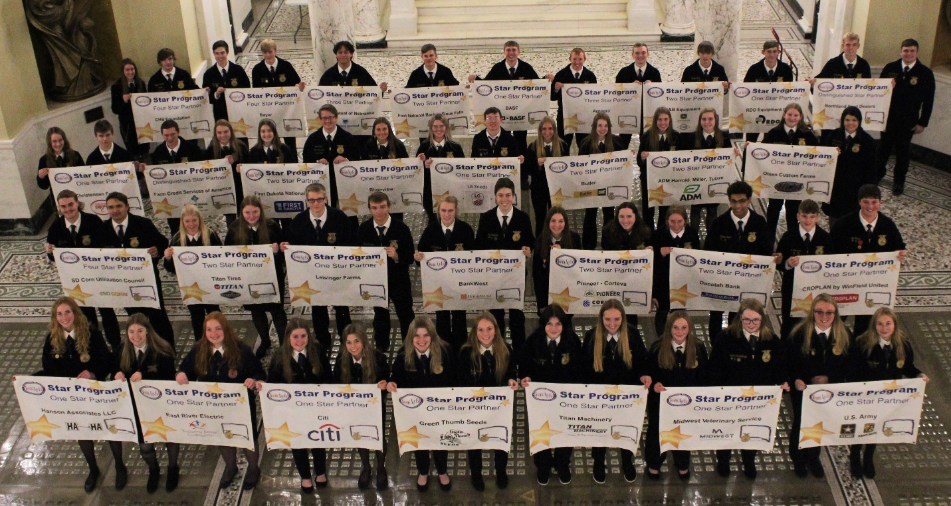
Photo Caption: SD FFA district officers attended a District Officer training and participated in a legislative breakfast, January 12th, 2023, advocating for agriculture education. These events were sponsored in part by the SD FFA Star Partners.

